is celebrating its 10th year!

To celebrate we are opening 16 homes across
London showcasing a wide range of eco-friendly technologies

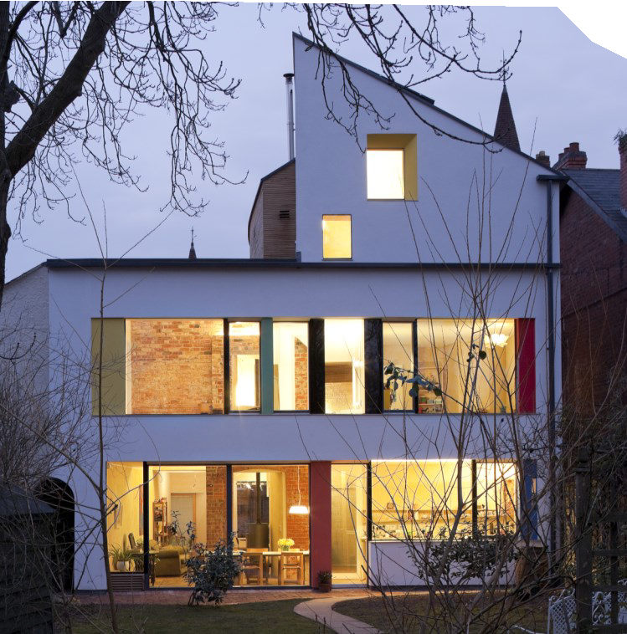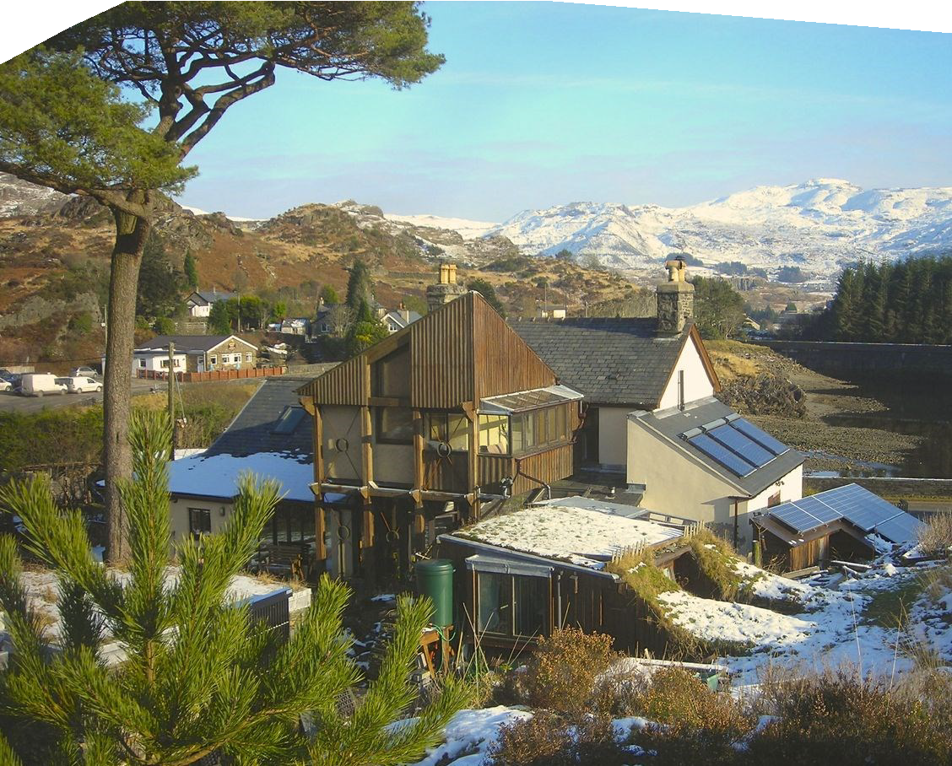

www.superhomes.org.uk
SuperHomes are older homes which have been renovated by their owners to achieve a minimum 60% reduction in carbon emissions.

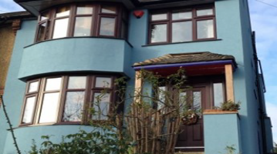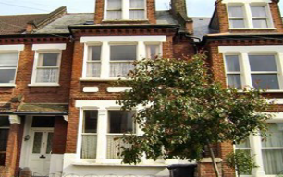

FREE Open Days this September 16th &17th
In Herne Hill, you will find Julie Codet-Boisse and Ben Murray.
Julie and Ben needed to completely renovate their home and took the
opportunity to reduce its impact on the environment by installing a number of energy efficient measures including a Solar Thermal system used to absorb and transform the suns energy to heat their hot water and an envelope method of insulation covering the floor, roof and external walls.

In In Catford you will find Peter Clifford
and Gretchen de Soriano who have retrofitted their 1930s 3
3 s storey home. Peter and Gretchen moved into their home almost 30 years ago when it was draughty and cold. The measures they have taken to improve its energy efficiency such as using a
wood burning stove have made it much warmer. The stunning blue external wall insulation invokes a feeling of being by the seaside and has wrapped up their home, preventing heat loss while adding to their comfortable retirement.

Honor Oak is home to P Paul Capel and Alice
Grahame’s detached house, a self-build home designed by famous architect, Walter Segal which they modernised to improve its eco-design by installing a range of energy
saving measures including a green roof and solar chimney which heats their home in winter and cools it in summer. Their home is truly unique as there are only a handful of Walter Segal houses and the property has been pushed towards the, very demanding, Passive House standard.
Directions to SuperHomes

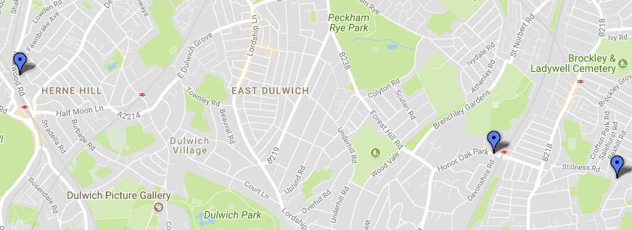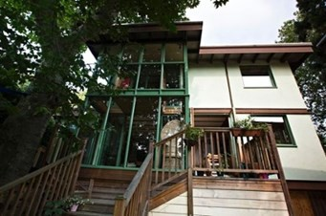Shardcroft Ave Herne Hill
Walters Way Honor Oak
Bankhurst Road Catford

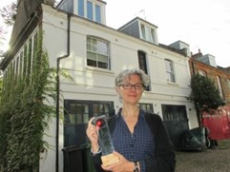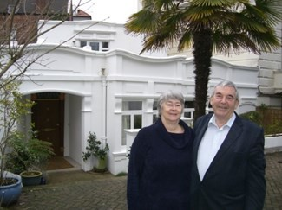

FREE Open Days this September 16th &17th
Sanya Polescuk redesigned the Victorian Mews house to provide home for her award-wining studio and an upper maisonette.
The original fabric of the house
has been preserved while introducing a contemporary sustainable agenda. Sanya redesigned the living space and installed insulation and mechanical ventilation heat recovery. To reduce reliance on fossil fuels, the couple use solar thermal, only A-rated appliances and low energy lighting.

A short stroll away from Sanya and Nigel, lives John
Doggart in his Victorian detached home in Belsize Park Gardens.
John’s home has a Mechanical Ventilation Heat Recovery system, an innovative way to remove moisture and stale air
along with odours and pollutants John’s passionate about conserving energy and his retrofit helps him save energy on a daily basis.

Highgate is home to The Clyne Family who live in a
a Council owned Victorian terraced property in a conservation area. The retrofit for their home was made possible after Camden Council secured funding from Retrofit for
the Future – a project which has reduced the property’s carbon emissions by 80%. Their home is now fitted with internal wall insulation which has dramatically reduced heat loss and was carried out with little disruption allowing the family to continue living at home.
Directions to SuperHomes

Bertram Street Highgate

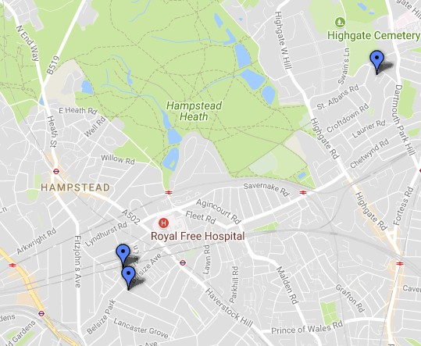Belsize Court Garages Belsize Park

The Coach House Belsize Park Gardens

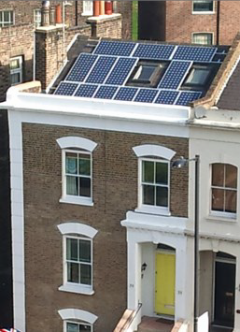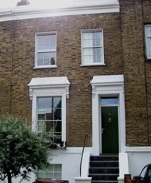

FREE Open Days this September 10th, 16th,17th, 23rd, 24th
De Beauvoir Town is home to Robert Cohen and Bronwen Manby’s 1830s mid terrace 4 storey home which features a variety of insulation measures to keep it airtight, in fact, their house is so energy efficient
that they receive negative energy bills from the energy produced by their solar PV. As Robert is an energy consultant, it’s unsurprising that he’s obsessed with the households energy use, he’s even co-authored two papers about the design and operational performance of the house.

In Dalston lives Dave Raval in his 1870s Victorian 4 storey town
to house which features water b based underfloor heating, a
1500L rainwater tank and a wormery which has left previous visitors fascinat- ed. Dave has been passionate about the environment since a teen and retrofitted his home to demonstrate that anyone can
turn a home with poor environmental standards into one that produces and consumes clean energy.

In Archway, you will find a 1860s end of terrace home belonging to Kate Calvert who has been working to improve its
warmth and necessary refurbishments since it was purchased over 30 years ago. During the works Kate has learned that her property was damaged in WW1 and was overcrowded with Edwardian
workers and their families. Kate has since fitted solar panels and carried out a range of insulation measures, including External Wall Insulation, to keep her home cosy throughout the winter.
Directions to SuperHomes

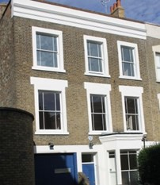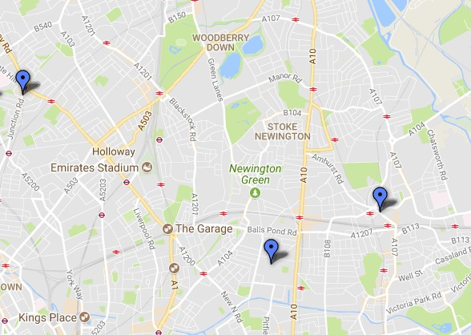
Hargrave Road Archway

Culford Road De Beauvoir Town

Amhurst Road Dalston

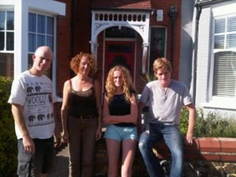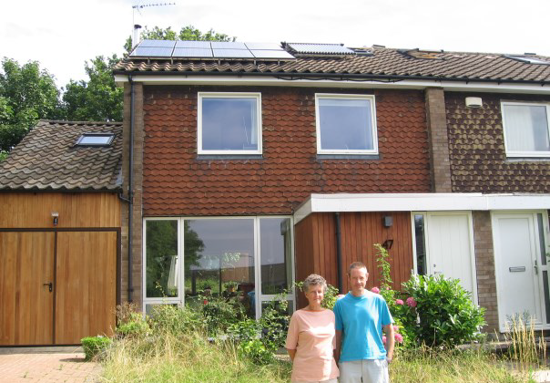

FREE Open Days this September 10th,16th, 17th
Grosvenor Road is home to The Mcilroy family’s Edwardian end of terrace
home. The Mcilroy’s retrofit was inspired by their passion
for environmental issues and have installed two wood burning stoves on each floor which has not only added to their home’s comfort but is an environmentally friendly alternative to heating your home than using gas and electricity. They also have a unique green roof made from recycled wool carpets which hosts a variety of plants and wildlife for added insulation while supporting local wildlife.

Heath View is where you’ll find architects, Mary Hogben and
Peter Hale who live in a1960s two storey property. Mary and Peter have a long interest in healthy homes and have chosen to use
Knauf white wool and wood fibre to insulate theirs, saving on their heating bills and adding to their home’s comfort.

In Yewtree Close you will find Lucy Craig and Gordon
Best’ Best’s 1980s stunning timber framed bungalow
which features a range of innovative energy saving measures and technologies including an air source heat
pump and internal wall, floor and roof insulation. Their favourite feature is the kettle tap which produces sterile hot water, preventing the need for an energy hungry kettle. Lucy and Gordon completed their retrofit after downsizing their family home which has helped them to save on their utility bills as well as reduce their impact on the environment.
Directions to SuperHomes

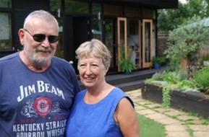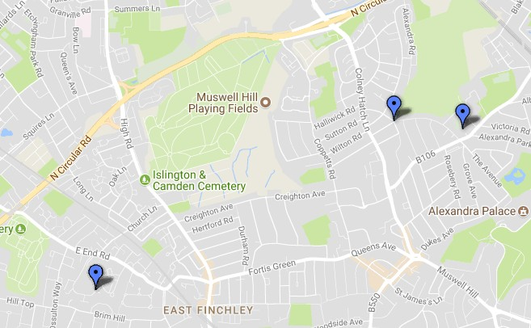
Heath View East Finchley

Grosvenor Road Muswell Hill
Yewtree Close Muswill Hill

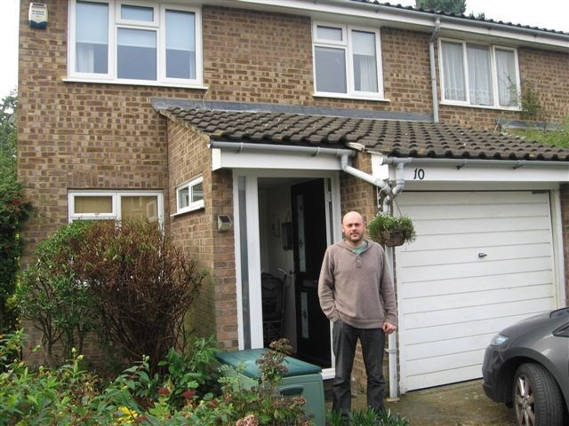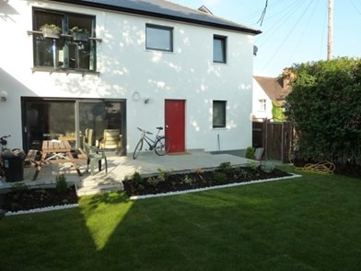

FREE Open Days this September 16th & 17th

Ealing is home to Dora
and Zsolt Varszegi who live in a 1920s semi-detached
ex-council property and the first Certified PassivHaus in the area. Dora and Zsolt are
both IT engineers and Zsolt is also a medical doctor. As they were on a limited budget, the couple did the organisation
and research work and weren’t afraid to get their hands dirty. Dora and Zsolt have not needed to turn on the heating for four years in a row as a result of the changes they have made.

In Ickenham, Gavin Roberts em- barked on a retrofit of
his home to achieve his desire of reducing his carbon footprint but since having a family, wants to protect them from rising energy bills. Gavin has a solar thermal system which converts over 90% of the heat it
generates into hot water for use in the household.

On Weir Hall Road you will find Pamela Harding and her 1920s ex-council home which has an incredible100% carbon
saving. Pamela’s visits to other open homes inspired the retrofit of her own home. The triple glazing is Pamela’s favourite feature allowing her to have sizeable windows and a
glass garden door opening up her home to the garden.

Simon Burton’s Edwardian top floor flat has wonderful views of St Pancras Station but before his retrofit it was very cold in winter. Simon has filled
his home with insulation keeping it cosy and warm and the new combi boiler has not only improved its energy efficiency but has also added more storage space.

Directions to SuperHomes

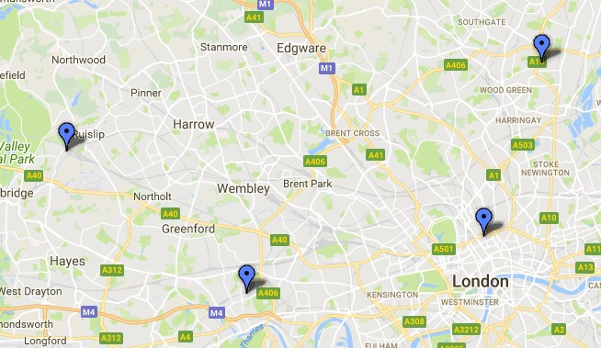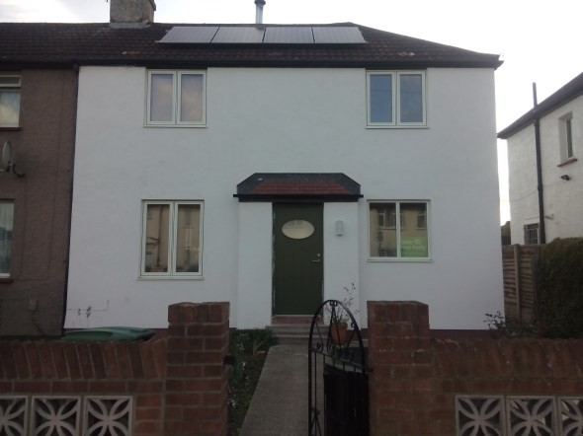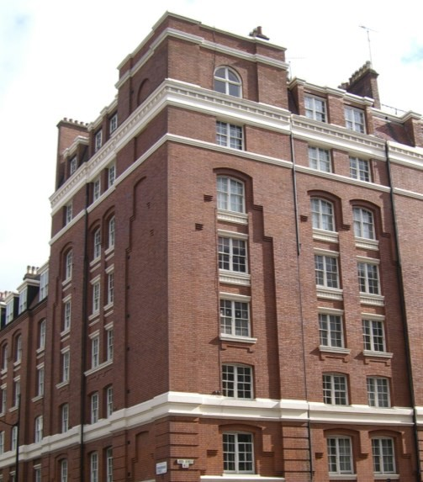Haslam Close Ickenham

Chestnut Grove Ealing
Weir Hall Road Edmonton

Judd St Kings Cross

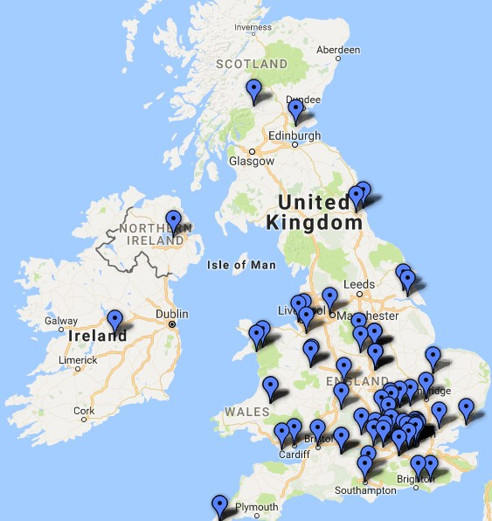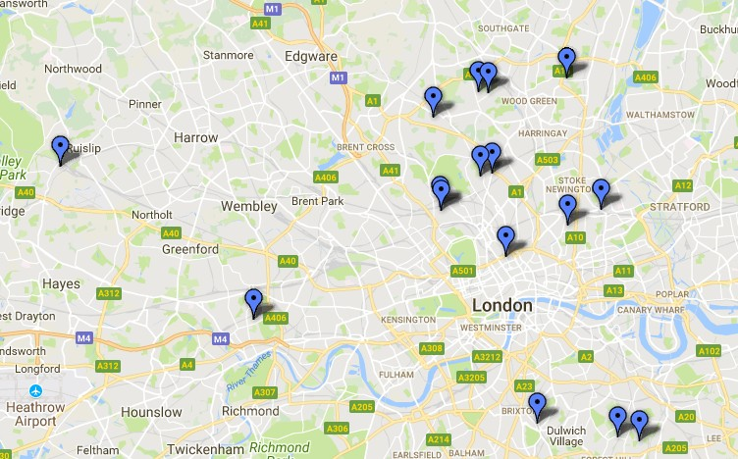

We have over 100 FREE events across the country

London
this September!
Register online
to secure your place
www.superhomes.org.uk

Opening doors to
low energy refurbishment

www.superhomes.org.uk

