Press Release
10 years of SuperHomes — 100 openings for 2017!

Date: 12 July 2017 Reference: SuperHomes 12 Jul 17
This year marks the 10th year of SuperHomes, the innovative and multi-award-winning national network of over 200 homes that have all reduced their carbon footprint by a minimum of 60%. To celebrate turning 10, SuperHomes is revitalising grassroots renovation with a record number of 100 FREE Open House events later this year across all parts of UK. Visit the SuperHomes website to find out more.
Since 2007, SuperHomes has been at the forefront of domestic eco-retrofit and the network continues to lead the way in carbon-conscious renovation. So far, 222 homeowners have all transformed their properties through environmentally-minded renovation, resulting in lower energy bills, smaller carbon footprints and a huge increase in comfort levels.

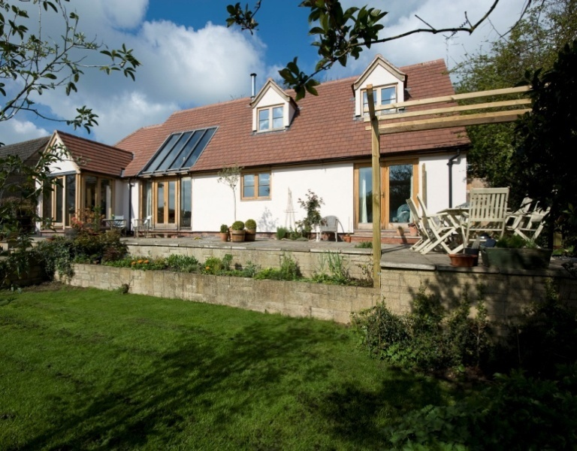
First time opener
SuperHome #220 in Evesham,
Worcestershire.
This 1968 bungalow has achieved
69% carbon savings.

SuperHomes include all types of houses, ranging from Grade II-listed 16th Century ironstone properties to ex-council houses built in the 1990s; from 6-bedroom Victorian mansions to 1940 terraces; from idyllic ecolodge retreats in rural Snowdonia to single-storey flats in the heart of London.
The technology used within and around SuperHomes is innovative and market-leading, and they offer exceptional, and often unique, examples of green technologies in the UK. In addition to the more mature aspects of green renovation, such as external wall insulation, solar PV panels and heat pumps, SuperHomes boast a variety of cutting-edge technologies such as Mechanical Ventilation Heat Recovery (MVHR) systems, green roofs, biomass boilers, and even whole-house airtight membranes. SuperHomes are pioneers in renewable technology and energy efficiency. Our most recent addition (SuperHome #222) is carbon neutral!
The FREE Open House events occur every September to inspire visitors to make their homes greener and more sustainable. The SuperHome owners provide honest and detailed accounts of their renovation stories, and offer invaluable advice and guidance for anyone wanting to follow in their footsteps.
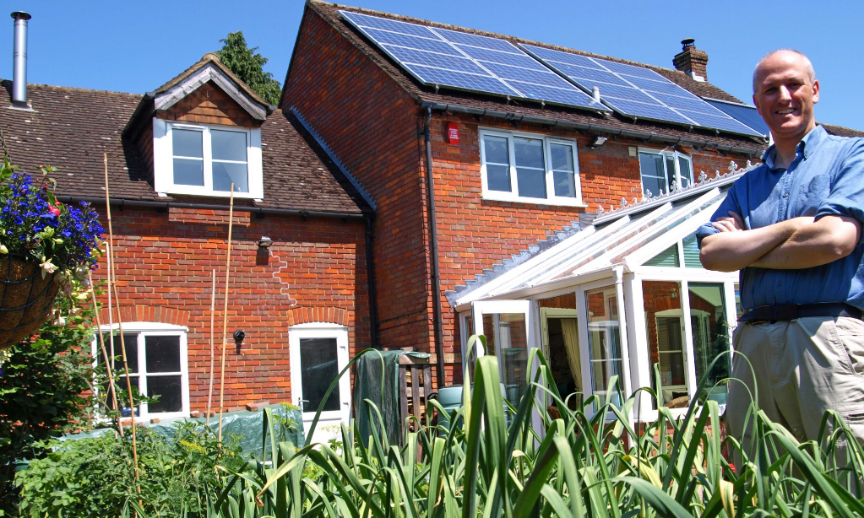
The current, post-Green Deal, climate, with lowered green incentives and a distinct lack of interest from subsequent governments, has seen the focus on eco-retrofit waver. Yet the refurbishment of our homes and buildings is one of the greatest challenges we face to reducing carbon emissions and tackling climate change. SuperHomes harnesses the enthusiasm of our energy-saving pioneers to stimulate community-led renovation.
SuperHome owner #59. Mark Brown stands in front of his 1980s detached house. This High Wycombe property has achieved 90% carbon savings.
Founder of the project (and owner of SuperHome #42), John Doggart, said:
“Thousands of people attend our SuperHomes each year and visitors typically go on to invest over £4,000 on energy improvements. This is a fantastic way of helping people to improve their comfort and fuel bills whilst making a vital impact on reducing climate change. Go visit one of the properties and see for yourself.”
To help SuperHomes celebrate this astounding anniversary we’ve partnered with the Ecology Building Society who are supporting this year’s September openings.
Ecology, a pioneering financial mutual, is dedicated to improving the environment by supporting and promoting ecological building practices and sustainable communities. It achieves this by providing mortgages for environmental improvements, energy-efficient renovations and self-builds for individuals, charities and sustainable businesses, as well as supporting affordable and community-led housing.
SuperHomes and Ecology have overlapping visions. We are both appalled by how much energy is wasted by houses across the UK; we both know that properties can be converted and renovated with respect for the environment, and with comfort and affordability in mind; and, most importantly, we both want to spread the message of eco-retrofit and inspire others to reduce their carbon footprint.
Paul Ellis, Chief Executive of Ecology Building Society explained why they are supporting SuperHomes this year:
“We’re really delighted to partner with SuperHomes in their anniversary year, by supporting their programme of September openings. Improving the energy efficiency of our homes and buildings is key to reducing our carbon emissions and tackling climate change and we believe that the SuperHomes network has an important role in showing what can be achieved.
“We are especially proud that some of the eco-renovation projects which our lending has helped to fund, are now SuperHomes themselves. We hope that Ecology’s support for the September openings will enable SuperHomes to reach even more people, inspiring them to renovate and retrofit their own homes while reducing their carbon footprint.”
We hope that this is the beginning of a longstanding collaboration between SuperHomes and Ecology. As the bulk of political attention is likely to focus on Brexit for the foreseeable future, we believe that building strong partnerships with like-minded organisations is crucial to influencing policy and shaping the future of environmental renovation.
SuperHome Open Days occur throughout the year with a co-ordinated national event throughout September. Most of our openings coincide with Heritage Open Days (7-10th September) and London Open House (16-17th September). Visit our website to find out more.
For further information, please contact:
Richard Vale, SuperHomes Project Manager
richard.vale@nef.org.uk
01908 256914

Notes to editors:
1. SuperHomes
SuperHomes are older homes that have been refurbished by their owners to the highest standards of energy efficiency. This means greater comfort, significantly lower running costs and a reduction in carbon emissions of at least 60%. SuperHome Open Days let visitors see for themselves both the challenges and benefits associated with making an older home energy efficient. Over 70,000 people have already visited a SuperHome. Currently, there are 222 registered SuperHomes and 85% of the population in England and Wales live within 30 miles of one. The network’s long-term objectives are to recruit 500 UK SuperHomes by 2020 and to attract 2 million visitors to SuperHomes (physical and online) by 2020. A 2016 report on the energy use of SuperHomes revealed that, on average, they use 40% less energy per square metre per year than the average UK home. SuperHomes is a National Energy Foundation project.
2. SuperHome Open Days
SuperHomes was the first national UK network of mostly privately-owned quality retrofits opened to the public. This year is our 10th year. Since 2007, SuperHomes has promoted the benefits of eco refurbishment using free Open Days, which offer a practical touch-and-feel experience. SuperHome Open Days let visitors see for themselves both the challenges and benefits associated with making an older home energy-efficient. They also make it possible to see retrofit technologies in situ in real homes. These include biomass boilers, heat pumps, mechanical ventilation and heat recovery systems and water-saving devices; as well as triple glazing, modern wood stoves and all types of insulation.
3. National Energy Foundation
The National Energy Foundation (NEF) is an independent, national charity based in Milton Keynes, and has been at the forefront of improving the use of energy in buildings since 1988. We aim to give people, organisations and government the knowledge, support and inspiration they need to understand and improve the use of energy in buildings.
4. Promotional Partners
SuperHomes also open as part of local green homes groups and national events such as Heritage Open Days (7 - 10 September 2017) and Open House London (16 - 17 September 2017). For the September 2017 events SuperHomes has partnered with Ecology Building Society.
5. Awards
SuperHomes has won many accolades, notably a Sustainable Energy Europe Award, a Gold Ashden Award and an International Green Award.
6. The Big Picture
The UK’s government is committed to a target 80% reduction in carbon emissions by 2050. New-build homes will not provide the answer. The UK’s 25 million homes currently account for at least 27% of UK carbon emissions. It is estimated that as many as 80% of all homes that will be in standing in 2050 have already been built. This means that retrofitting existing homes should be a priority if the government’s target is to be met. Of particular concern are the 7 million solid wall properties in the UK, most of which are expensive to heat and can be cold in winter. To meet the 80% carbon reduction target it is estimated that we should be refurbishing 600,000 homes a year, making them energy-efficient. The homes of the future will necessarily be dramatically improved older homes - like SuperHomes.

